**ASSIGNMENT-3**

**PROGRAM-1**

**WRITE A PROGRAM IN C TO STORE ELEMENTS IN AN ARRAY AND PRINT THEM**



**OUTPUT:**

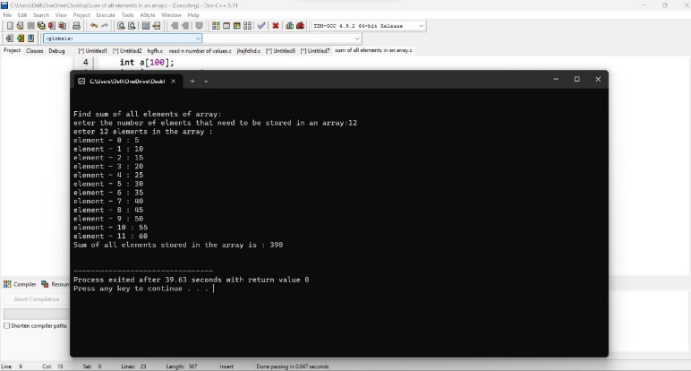

**PROGRAM-2**

**WRITE A C PROGRAM IN C TO READ n NUMBER OF VALUES IN AN ARRAY AND DISPLAY THEM IN REVERSE ORDER**



**OUTPUT:**

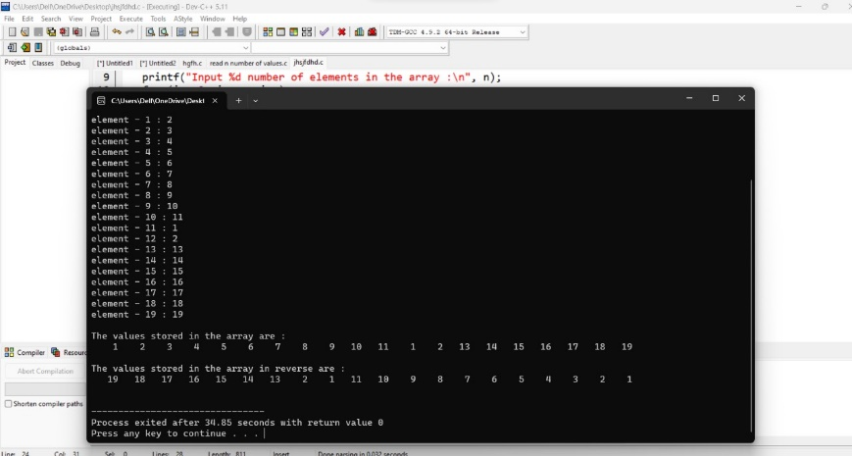

**PROGRAM-3**

**WRITE A PROGRAM IN C TO FIND THE SUM OF ALL ELEMENTS OF THE ARRAY**



**OUTPUT:**

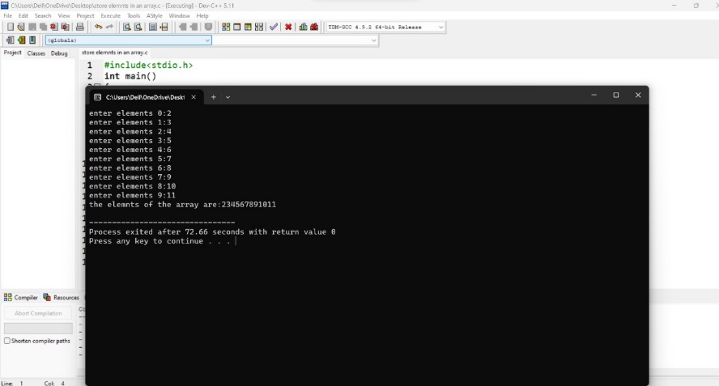

**PROGRAM-4**

**WRITE A PROGRAM IN C TO COUNT THE TOTAL NUMBER OF DUPLICATE ELEMENTS IN AN ARRAY**



**OUTPUT:**

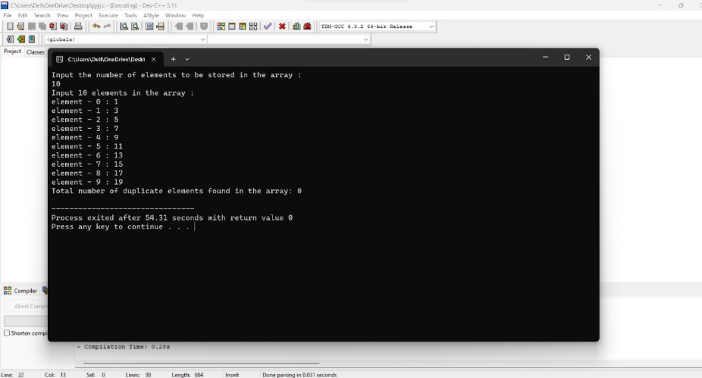

**PROGRAM-5**

**WRITE A PROGRAM IN C TO PRINT ALL UNIQUE ELEMENTS IN AN ARRAY**



**OUTPUT:**

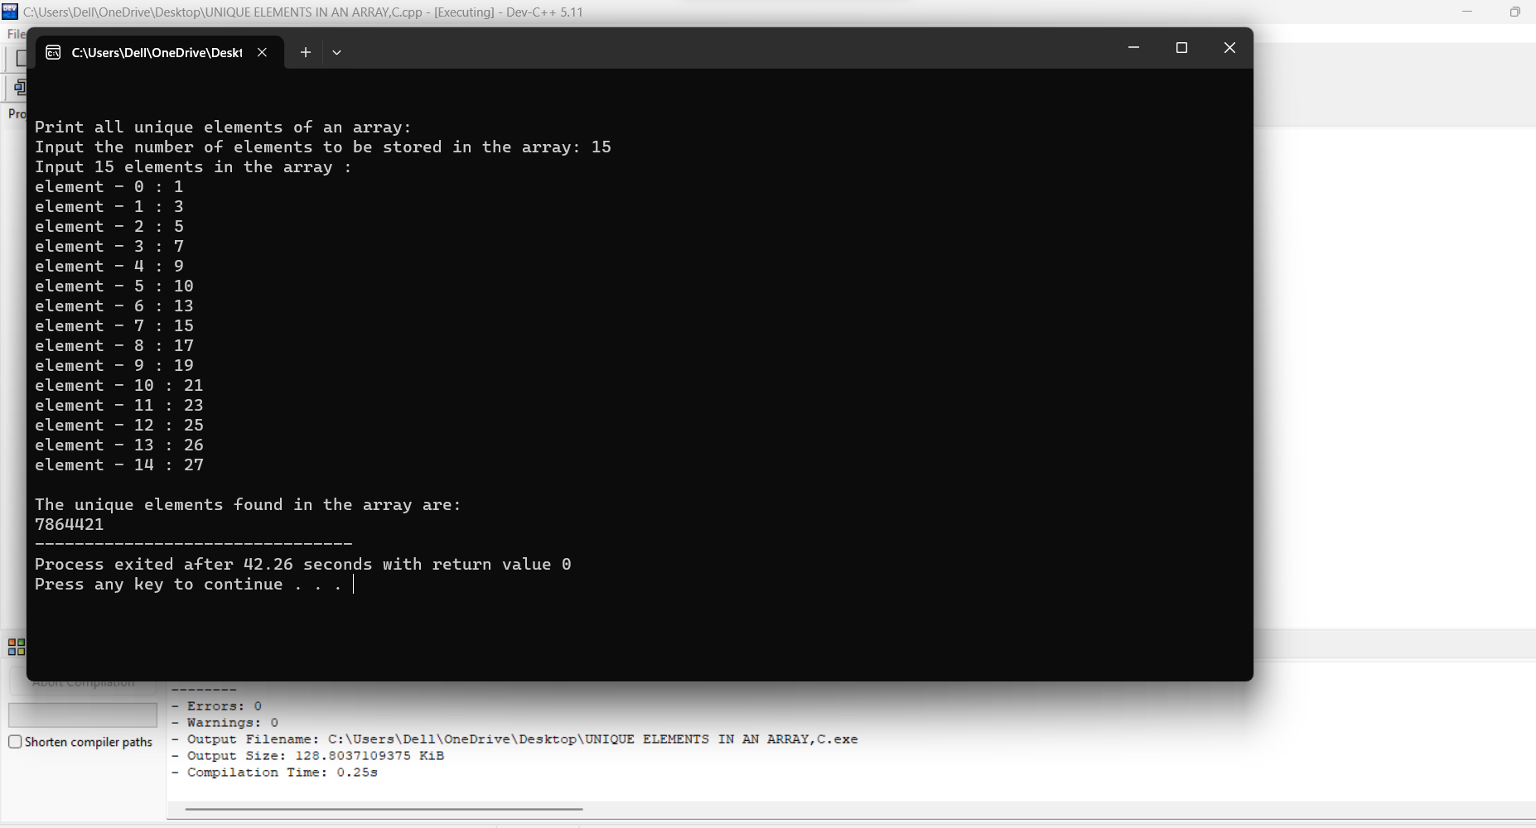

**PROGRAM-6:**

**WRITE A PROGRAM IN C TO INSERT AN ELEMENT INTO AN ARRAY AT A SPECIFIED POSITION**



**OUTPUT:**

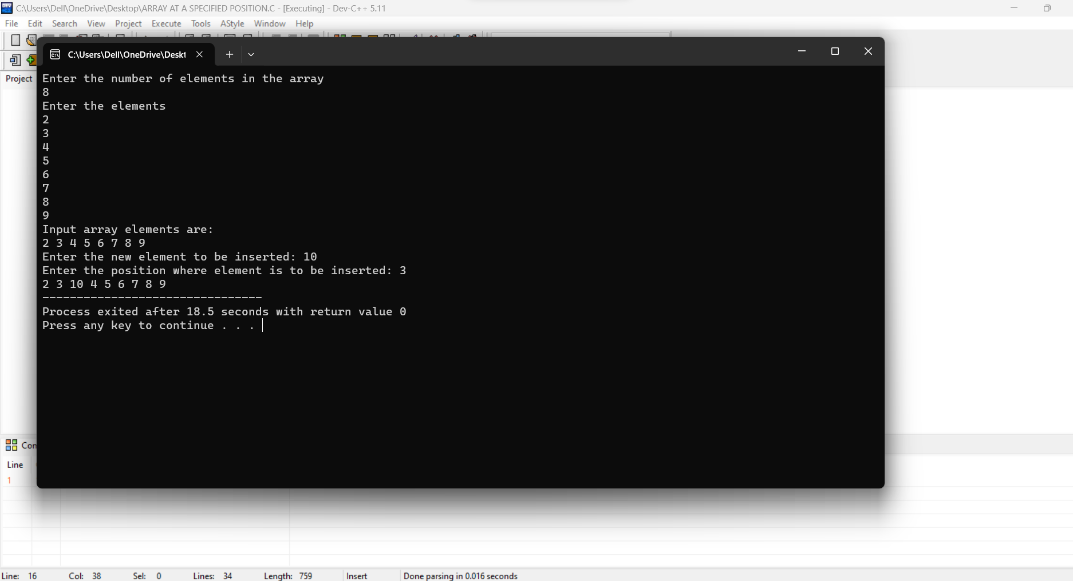

**PROGRAM-7**

**WRITE A PROGRAM IN C TO DELETE THE ELEMENT AT THE GIVEN INDEX**



**OUTPUT:**

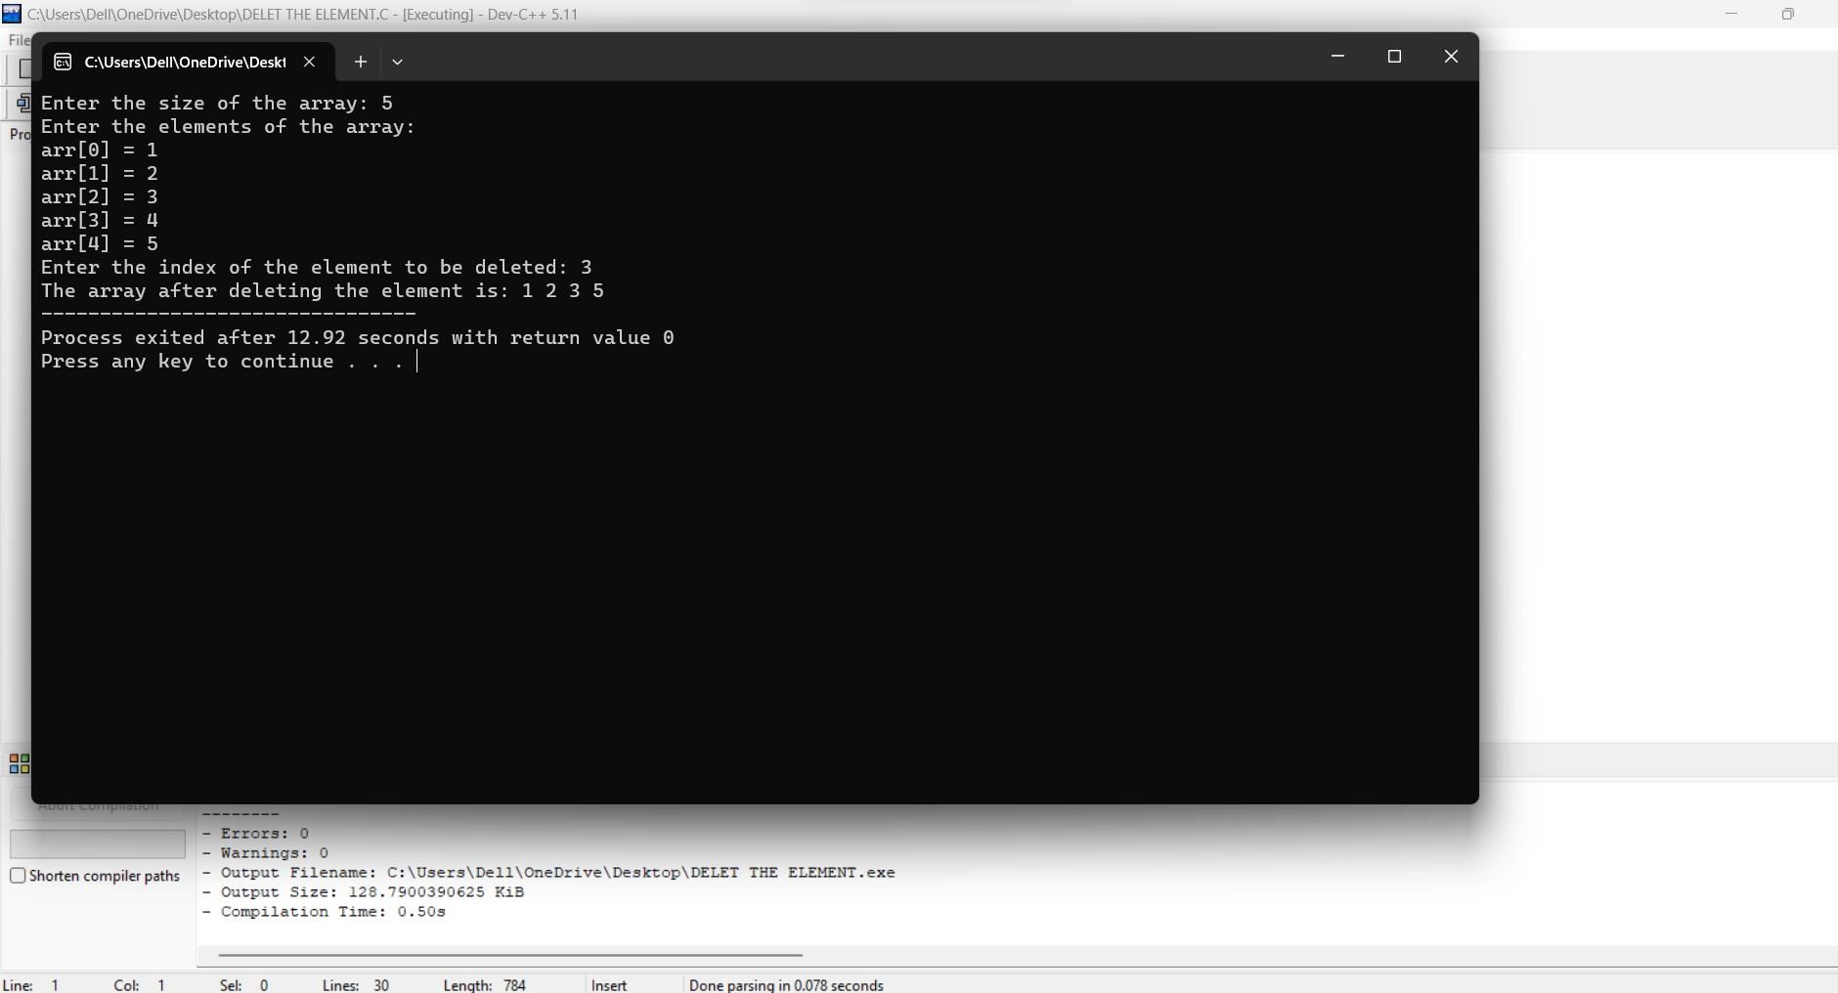

**THE END**